**Country Program**

India

**Accused**

Name: Prateek Pawa

Photo: N/A

Physical Description: 175 cm tall

Distinguishing Features: dark mark on left cheek

Date of Birth: January 16, 1983

Age: 35 years old

Sex: Male  
Place of Residence: 14 High Palace, Upper Parel, Adrash Nagar, Worli, Mubai, Maharashtra

Occupation: E-Commerce

**Arrest**

Date of Arrest: December 27, 2015

Location of Arrest: Place of Residence

Arresting Officer: Mumbai Police, District 21

Crime being accused off: Murder

**Accuser**

Name: N/A

Age: N/A

Sex: N/A

Other Details: Public Investigation to the death of Mark Hobbes, an American tourist

**Detention**

Current Detention: Mumbai Central Jail

Detention Center Contact: Sai Petal

Special Note: High Security Prison

Moved here: January 1, 2016

Signs of Torture: none beyond original

Previous Detention: Unknown Location

Detention Center Contact: N/A

Special Note: Accused was taken to an unknown location upon arrest.

Moved here: December 27, 2015

Signs of Torture: Yes, lashes over back and broken fingers

**Status**

Trial Date: January 2, 2018

Detention: officially since January 1, 2016

Sentencing Terms: life sentence with a minimum of 30 years sentence

Release: earliest January 3, 2048

**Public Defender**Name:Prateek Pawa (PD)  
Photo: 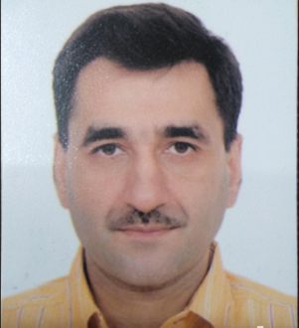  
Affiliation: Indian Bridges to Justice Lawyer Pro-Bono lawyer

**Prosecutor**

Name: Prathana Agrawal

Special Note: N/A

**Judge Assigned to Case**

Trial Judge: Arjun Mehta

Special Note: M/A

**Case Contact**

Name: Prathana Pawa

Affiliation with Accuse: Mothher

Contact Information: +9139592991  
Address: 14 High Palace, Upper Parel, Adrash Nagar, Worli, Mubai, Maharashtra

First Contact: hotline on March 15, 2018

Last updated on accused status: Novemer 22, 2018

*Emergency Contact*

Name: Pranee Pawa

Affiliation with Accuse: Grandmother

Contact Information: +9139592991

Address: 14 High Palace, Upper Parel, Adrash Nagar, Worli, Mubai, Maharashtra

Special Note: N/A

**IBJ Case Supervisor**

Name: Katyani Verma

Affiliation: Staff, India Bridges to Justice

Contact Information: +91239938007, katyaniver@gmail.com

Last log-in: December 10, 2018